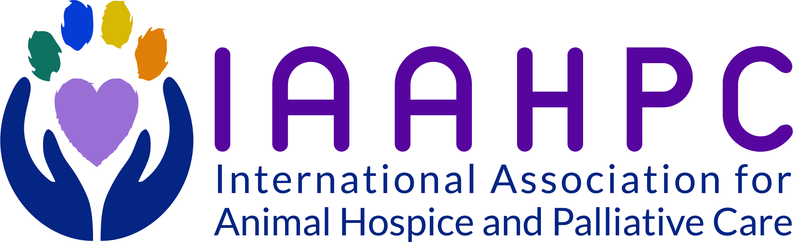

Social Worker Certificate Student Application
Thank you for your interest in completing the Animal Hospice and Palliative Care Certificate for Social Work!
Please note: At present, program enrollment is limited to currently licensed Social Work professionals we are IAAHPC members in good standing
- Please complete the AHPC Student Application Form and email it to Stephanie@iaahpc.org.
- Along with the application, please also send the following:
  - Your completed Student Application Form
  - Photocopy of professional license (jpeg or PDF)
  - Resume/curriculum vitae (Word document or PDF)
Review of applications may take up to 1 week. Once your application is reviewed and approved, you will receive notification of acceptance to the program and provided with an opportunity to purchase and begin Modules 1-9 on our learning center website.
Because our 2020 annual conference will not be held in-person, you will take Module 10 and graduate at the 2021 Conference (September 9 to September 14, 2021 in Tampa, Fla). Modules 1-9 will need to be completed before September 1, 2021.
If you have any questions, you can contact Tammy Wynn (tammy@iaahpc.org) or Stephanie Jones (stephanie@iaahpc.org).

Application for enrollment in the Animal Hospice and Palliative Care Social Work Certificate Program

- Applicant Information:

Name: Click or tap here to enter text.
I am an: LSW ☐ LISW ☐ Other ☐
Business Name: Click or tap here to enter text.
Business Address: Click or tap here to enter text.
Business Phone: (xxx) xxx-xxxx
Home Phone/Mobile Phone:(xxx) xxx-xxxx
Email Address: your@email.com

- Professional Experience:

Academic Degree: Click or tap here to enter text.
Institution: Click or tap here to enter text.
Year Awarded: Enter year
Years in practice: Enter years
Please list field of current practice here: (Health, School, Veterinary Social Work, etc) Click or tap here to enter text.
Do you hold any additional Certifications? List here
IAAHPC Membership? Yes ☐ No ☐
Other Professional Memberships: List here
Briefly outline your experience in hospice and palliative care. Include information about training, work experience, writing, research and teaching, if applicable:
Click or tap here to enter text.

Have you ever had a professional license suspended, revoked or voluntarily relinquished? Yes ☐ No ☐
If yes, please explain:Click or tap here to enter text.

Have you ever been convicted of, or are you now under any charges for, any ethical violation? Yes ☐ No ☐.
If yes, please explain: Click or tap here to enter text.

- Application Requirements:

Please submit the following documents:
- Photocopy of professional license (jpeg or PDF)
- Resume/curriculum vitae (Word document or PDF)
- Passport-sized photograph (jpeg or PDF)

- Acknowledgement:

☐ I do hereby make a voluntary application for the AHPC Social Work Certificate from the International Association for Animal Hospice and Palliative Care (IAAHPC). I certify that the information given by way of this application is true, honest, and completely represents me. I understand and agree that if I am awarded the AHPC Social Work Certificate, I will conform to all applicable local and governmental regulations and will conduct my professional behavior consistent with the highest standards of professional conduct, as established in the Code of Ethics of the IAAHPC, as well as those codes of ethical conduct relating to my profession. I agree to abide by the regulations of the IAAHPC and I recognize that failure to do so may result in suspension or revocation of my standing within this organization. I understand that any credential by the IAAHPC does not in and of itself imply or grant license to practice in any country or state. Furthermore, I understand and agree the IAAHPC and its affiliates assume no responsibility for my action or activities. I practice at my own risk and hereby release the IAAHPC from any and all liability from any practice decision I make in the practice of veterinary hospice and palliative care.

